NAME:VENKATRAMAMOORTHY.G
- Extract values from an array/object using destructuring.
CODE:
let arr=[1,2,3];
for(let i=0;i<arr.length;i++){
console.log(arr[i]);
}
console.log('array using destructing');
const arr1=[1,2,3];
const [a,b,c] =arr1;
console.log(a);
console.log(b);
console.log(c);
console.log('Object Destructuring');
const obj={name:'venkat',age:21,gender:'male'};
const {name,age,gender}=obj;
console.log(name);
console.log(age);
console.log(gender);
OUTPUT:
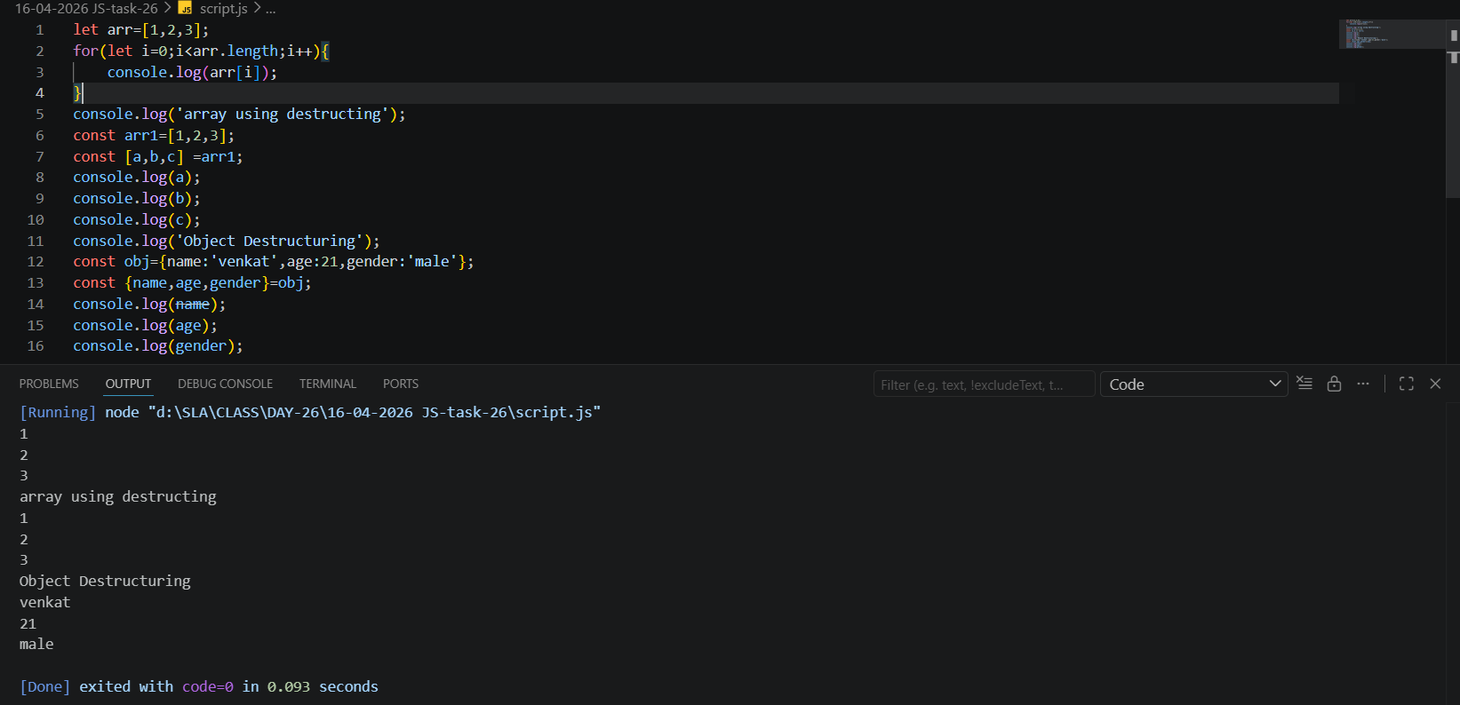
- Copy an array using spread operator.
CODE:
const orginal=[1,2,3];
const copy=[...orginal];
copy.push(4);
console.log('using spread operator dont change orginal arr');
console.log(orginal);
console.log(copy);
OUTPUT:
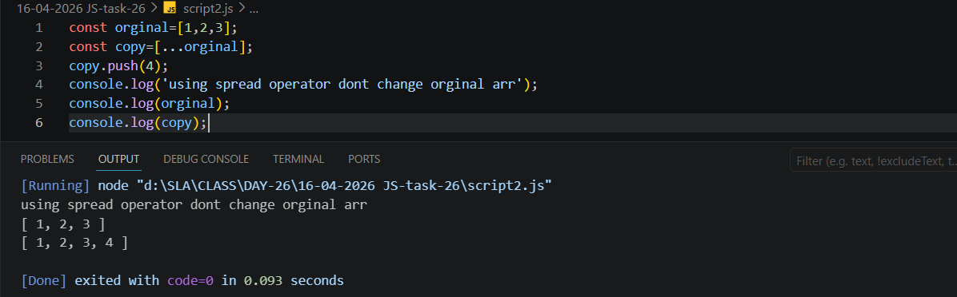
- Write a function using rest operator.
CODE:
function add(...numbers){
let total=0;
for(num of numbers){
total+=num;
}
return total;
}
console.log(add(1,2,3));
console.log(add(10,20,30,40));
OUTPUT:
